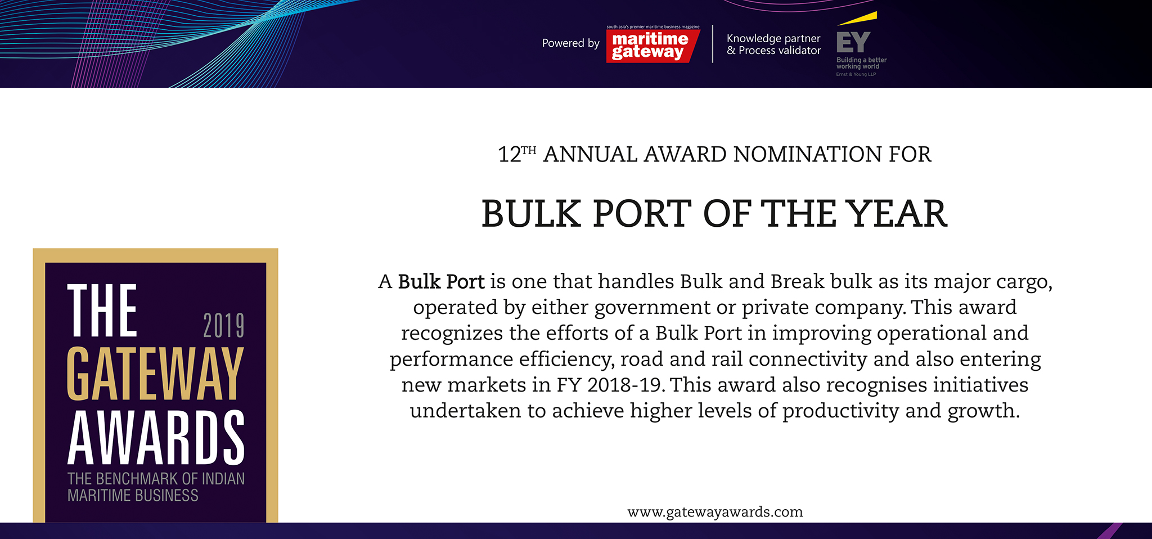

Please fill your responses and mail it to the address mentioned at the end of the Questionnaire

Note: All information and data should be provided for the FY 2018-19. In case, if you are unable to provide FY2018-19 data, CY2018 information can be sent with a reason for not providing data for FY2018-19.

Contact information:
Name of the Organization

Contact Person

Designation

Contact no.

Official Email ID

Address

Performance Indicators

Parameters | Units | Inputs
Throughput | Million Tonnes | Dry Bulk | Break Bulk | Liquid
Growth rate  (Y-o-Y, FY2018-19 over FY2017-18) | Percent
Installed Capacity | Million Tonnes
Capacity Added | Million Tonnes

Efficiency Indicators

Parameters | Units | Inputs
Capacity utilization | Percent
Average turnaround time | Days
Growth in Average Turnaround time  (Y-o-Y,FY2018-19 over FY 2017-18) | Percent
Average pre-berthing detention time | Days
Growth in Average pre-berthing detention time  (Y-o-Y, FY2018-19 over FY 2017-18) | Percent
Average output per ship berth day | TEUs
Growth in Average output per ship berth day  (Y-o-Y, FY2018-19 over FY 2017-18 in million tonnes) | Percent

Infrastructure Enhancements

Parameters | Type of inputs needed | Inputs
Commissioning of additional  infrastructure | New Cargo Evacuation  Infrastructure(Conveyer Belts,  Oil pipelines..etc.)
Construction of new berths | Number of berths and capacity added
New Services and routes added | Service Name ( ex: CIX  express) and Port callings
Connectivity Improvements | New Road and Rail  connectivity added
Entry in new global market | Name of the countries

Innovations/ Investments/ Enhancements

Parameters | Type of inputs needed | Inputs
Innovations | • Qualitative inputs  • Word limit ~ 200 words.
Business Processes
Efficiency
Technology
Investments made

Please use below contact for sending filled-in form and also for any queries.

Rakesh Oruganti | Cell: +91 99483 34568;E mail ID: rakesh.oruganti@gatewaymedia.in

